**Development of Asymmetric**

**Competitive Games Based on Bluetooth Technology**

**--Final Inspection Report**

Supervisor:Song Xuan

Team members:Jiang Yuchen,Chen Jiyuan,Huang Wenjie

# 1.Abstract

This is a report for the final inspection.Conclusions of the second inspection and work of final stage are concluded in passage.Futhermore,summary of this term and future work are written at the end of the passage.

# 2.Conclusions of 2nd Inspection

We are reminded that we are behind schedule and we need to focus on our aim which is to build up a hand motion detection system. We need to build up our deep learning model as soon as possible.

# 3.Literature Review

Based on the the literature before, we finally chose Bi-LSTM to apply on our system.

## A.Bilinear LSTM

Although traditional LSTM is sensitive to time sequence, it performs not well in real time recognition. In order to optimize the system, bilinear LSTM apply memory module as a part of classifier. Thus the system will get a better result. Here is the framework for Bilinear LSTM[2].

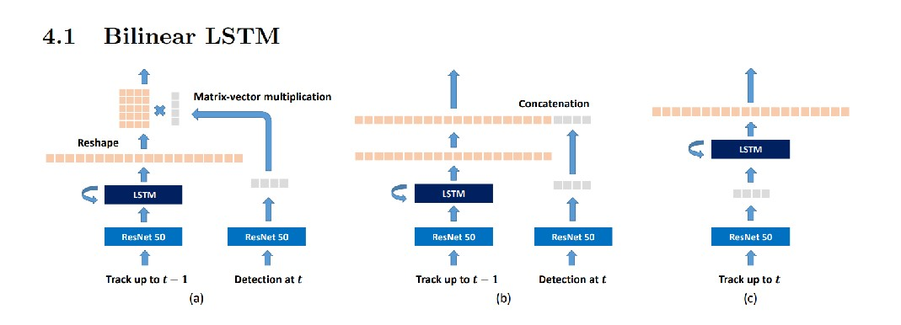

Fig.1 Framework of Bilinear LSTM[2]

Also, here is the experiment result of bilinear LSTM. IDF1 shows how well the methods perform with proportional relation.

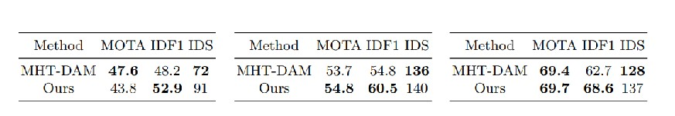

Fig.2 Experiment result[2]

# 3.Model Design

## A.Data set

Our data is collected from smart phones which provide many categories of data,such as acceleration and angular speed. Based on APP:phyphox which can collect data of smart phones in certain time sequence. Here is an example of one data set which are acceleration data without g in three axes. The corresponding hand motion is tick and there are 12 times of such motion in collected time sequence.

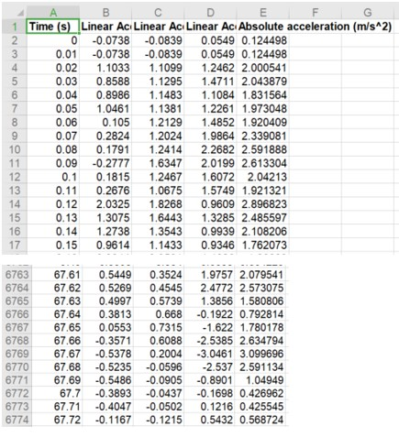

Fig.3 Current data set: acceleration data without g,hand motion: tick

We have designed 3 different hand gestures which we use to collect and clean data. The whole practice model is as follows. These three different hand gestures can be used to relate with game events.

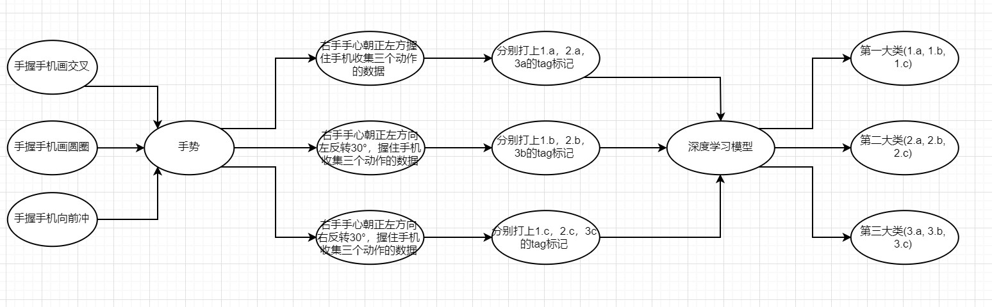

Fig.4 data collection flow chart

Here are also some constraints on data collecting. We define one motion time slot is 3 s. Since when experimenting we set collecting rate as 100 HZ, so we will get a piece of data every

0.01 s. Thus, for one hand motion there are 300 pieces of data.

We set our CNN channel as 20*20 so we will padding 0 for 50 times before and after the main data so that it can be accepted by defined channels.

Besides, when collecting data, the interval between two data should be above 2 seconds so that our program can partition it successfully and two motion interval will not interrupt.

## B. Pre-process of data

We apply smoothing and normalizing to preprocess the data before it is sent to model for training,

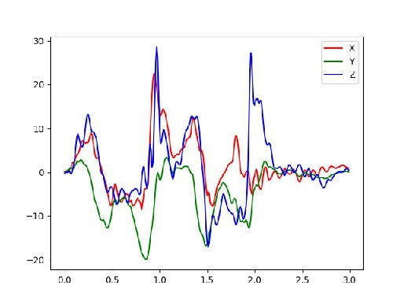

Fig.5 Raw data

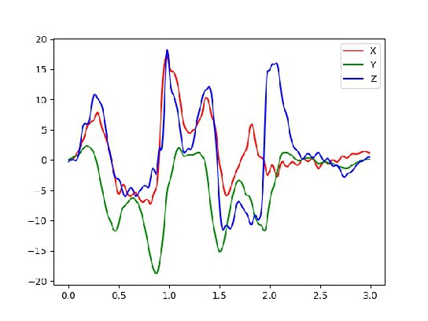

Fig.6 Smoothed data

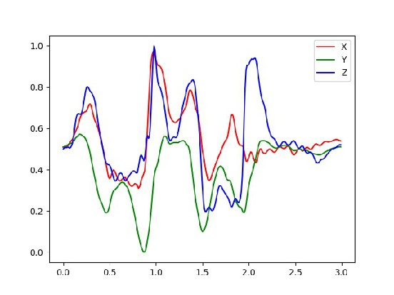

Fig.7 Normalized data

Figures shown above are three kind of data which are raw data, smoothed data and normalized data. Figures below shows the equations which are used to smooth and normalize.

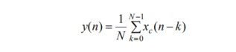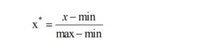

Fig.8 Equations[1]

## C. Deep Learning model

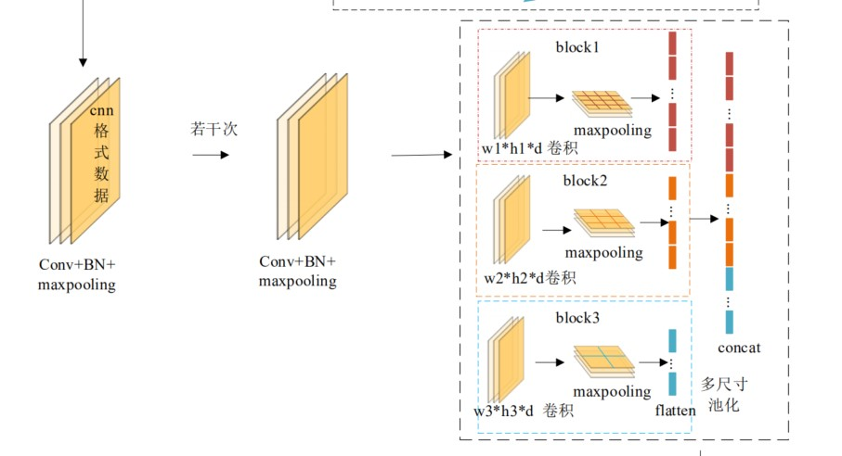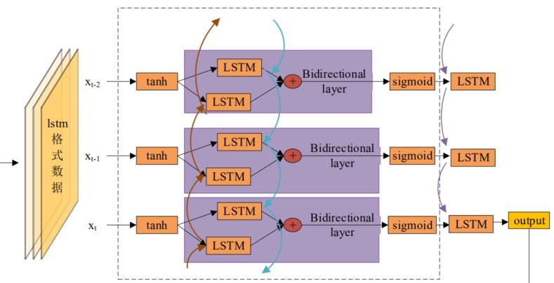

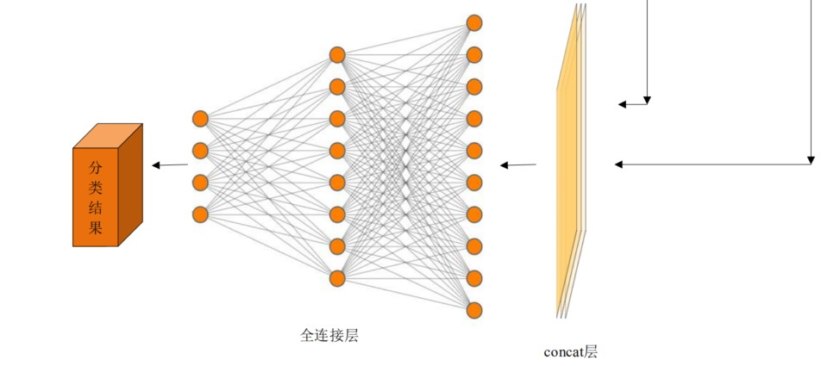

Fig.9 Neuronal network of CNN and Bi-LSTM[1]

Our neuronal network are designed as above. Training data will be run both in LSTM layer and CNN layer. Features which are output from CNN and LSTM will be combined to final layer.

## D. Training Result

We apply our training process on Google colab which provides us GPU resources to accelerate our training process. Here are partial views of training process.

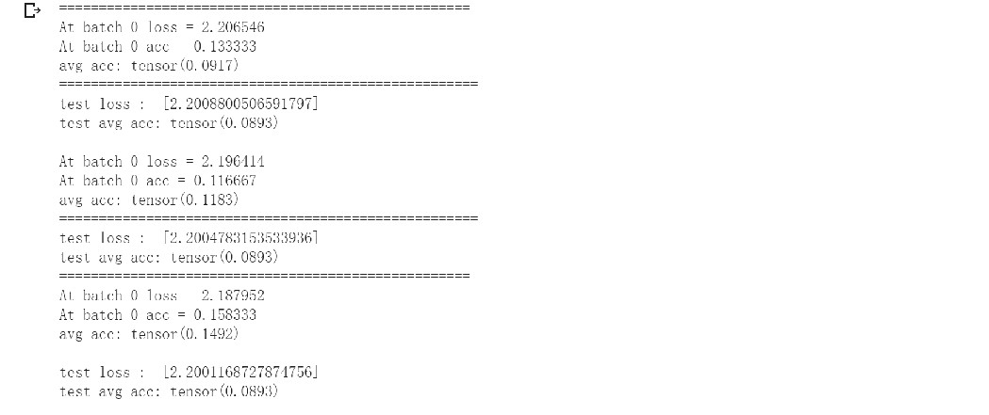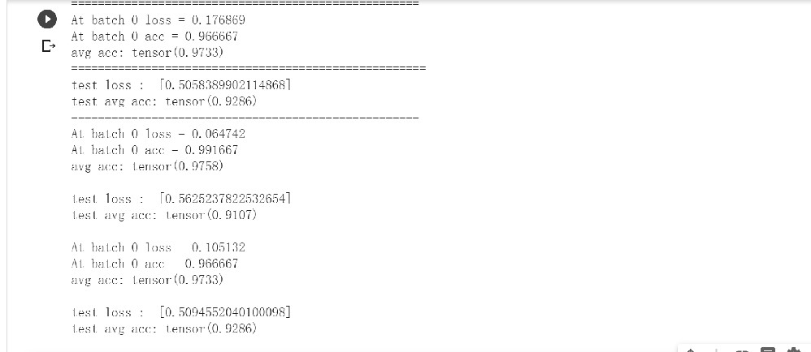

Fig.10 Training Result

At first, average accuracy is only 0.1492 and test average accuracy is only 0.0.893.

Finally, average accuracy is 0.9733 and test average accuracy is 0.9286, which is acceptable.

# 4. Summary

What we did this term?

## A.Patent work

Two patents are finished about our topic. Our group finished writing patent which is related to our topic——Development of Asymmetric Competitive Games Based on Bluetooth Technology.

Here is current state of patent work

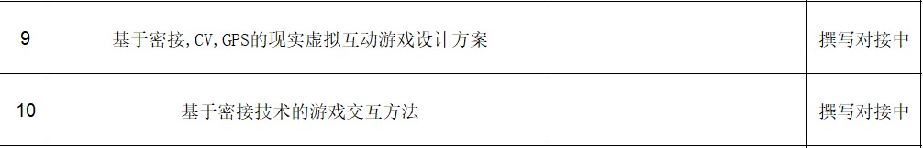

Fig.11 Current state of patent work

## B.Literature work

As shown above,we did further more literature work about our adjusted goal. We learned more about hand motion recognition and LSTM network,which is vital for us to build up our own deep learning model.

## C.Tentative draft of essay

We finished tentative draft of essay which is related to our topic. Abstract,introduction, related work parts and part of model design are finished. Here is a partial view of draft of essay.

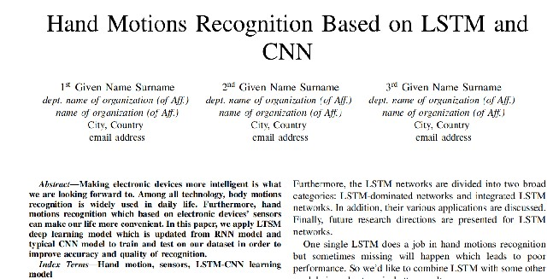

Fig.10 Partial view of draft of essay

## D. CNN-LSTM model

We learned pytorch by ourselves and build up our own deep learning model.

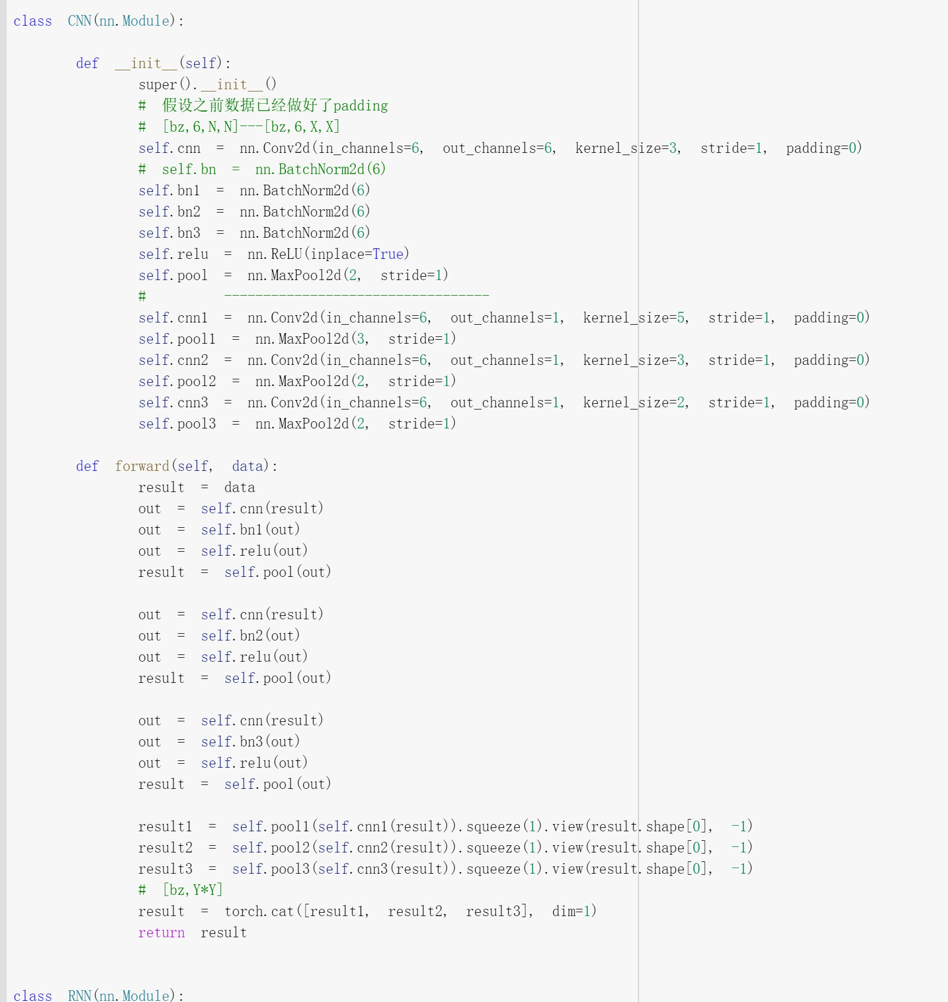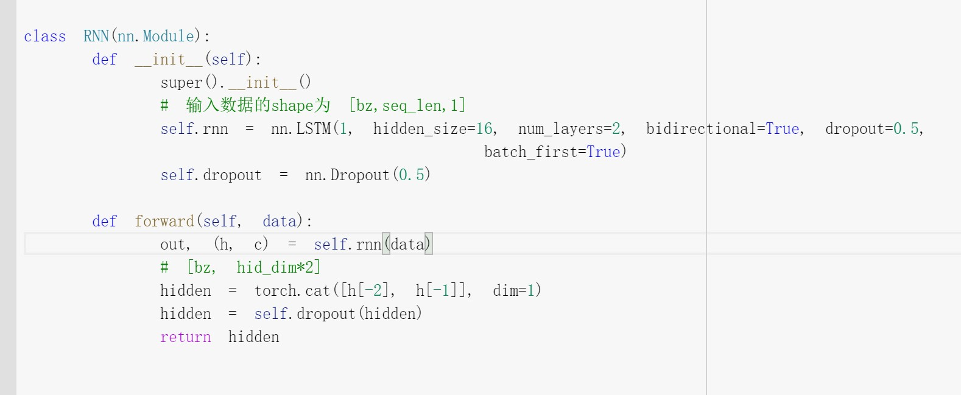

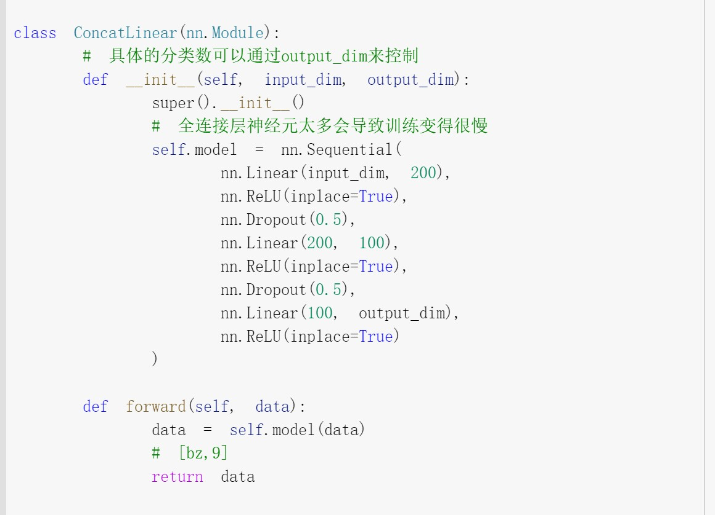

Fig.11 partial view of our test codes

## E. Find bugs and fix them

In our learning road we find lots of bugs and we fix them one by one. They help us a lot and we realize more deeply about deep learning.

For example, the size of batch matters and training result will be not good if batch size is not big enough.

# 5.Future Work

After the project ends, we will finish our experiment part in our essay so that it becomes complete.

If possible, we will get more data to enrich our model.

# 6.Reference

[1]龙秋玲.基于改进 CNN-LSTM 的人体行为识别研究[D].成都: 电子科技大学软件工程, 2020:35.

[2]Kim, C., Li, F., & Rehg, J. M. (2018). Multi-object tracking with neural gating using bilinear lstm. In Proceedings of the European Conference on Computer Vision (ECCV) (pp. 200-215).

***At last, thanks to all professors and seniors who give us great help in this term! Thanks for your help!***